Tugas PWPB Pertemuan 4

1. Grid Layout : https://github.com/aditpp/android_studio/tree/master/GridLayout
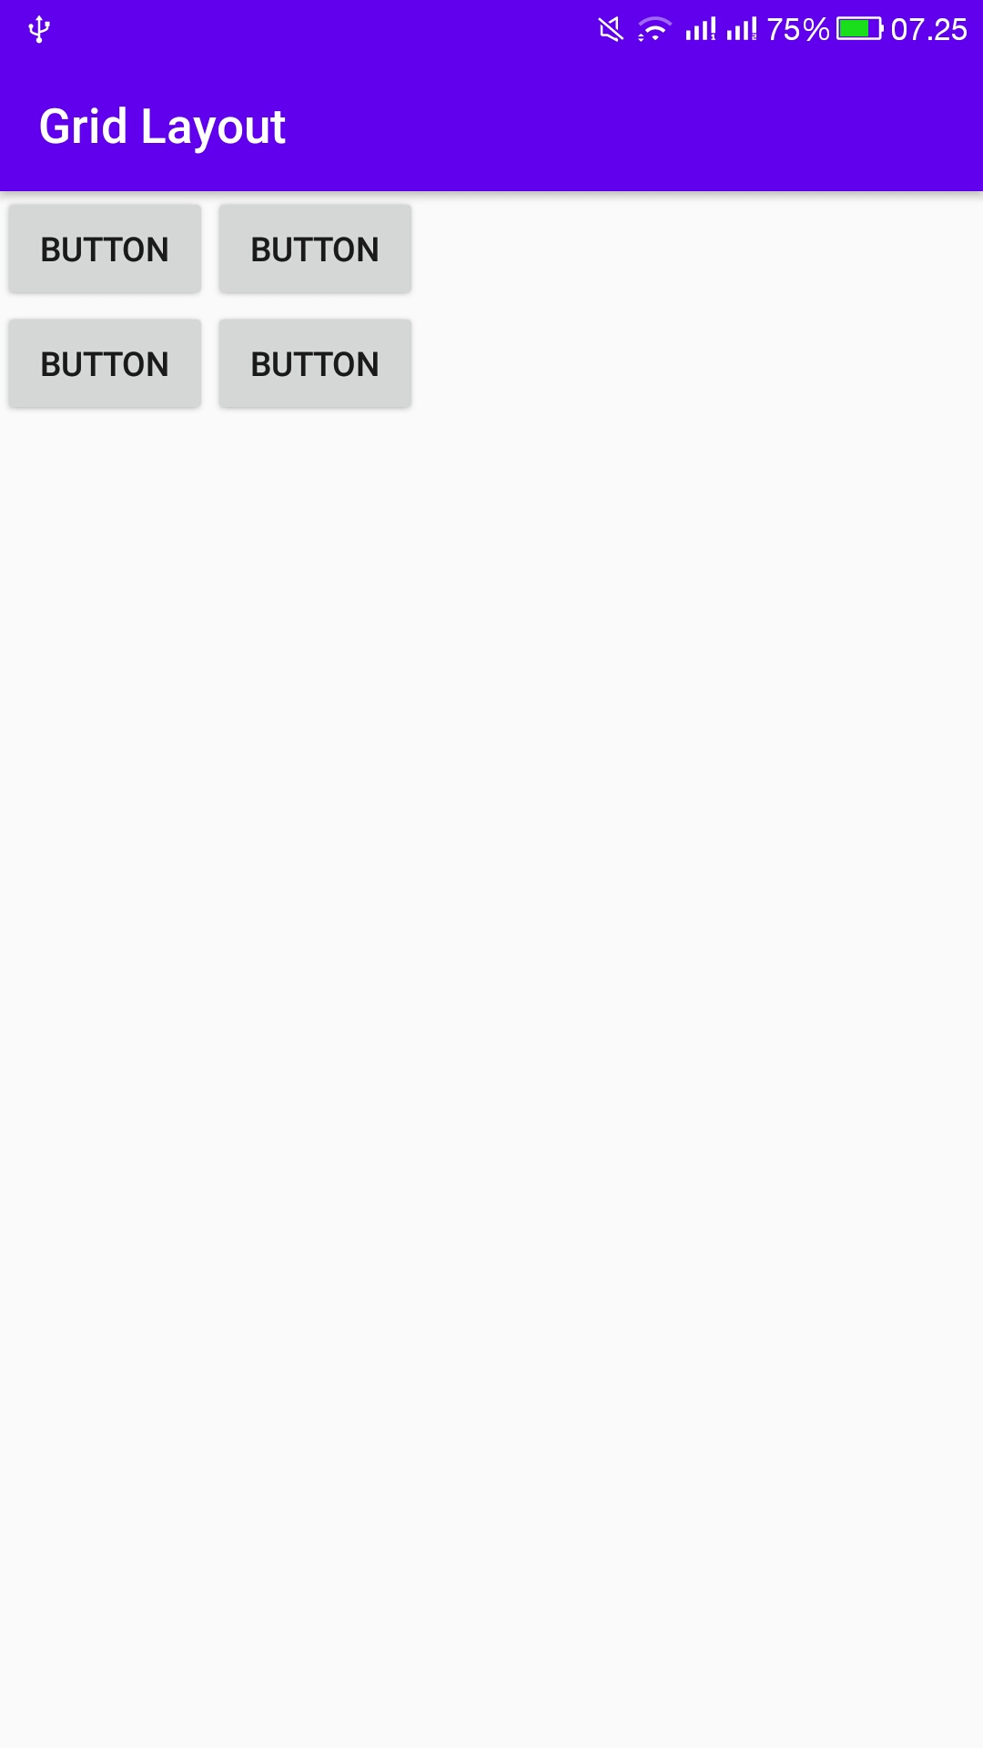

2. Soal Latihan Grid : https://github.com/aditpp/android_studio/tree/master/LatihanGrid

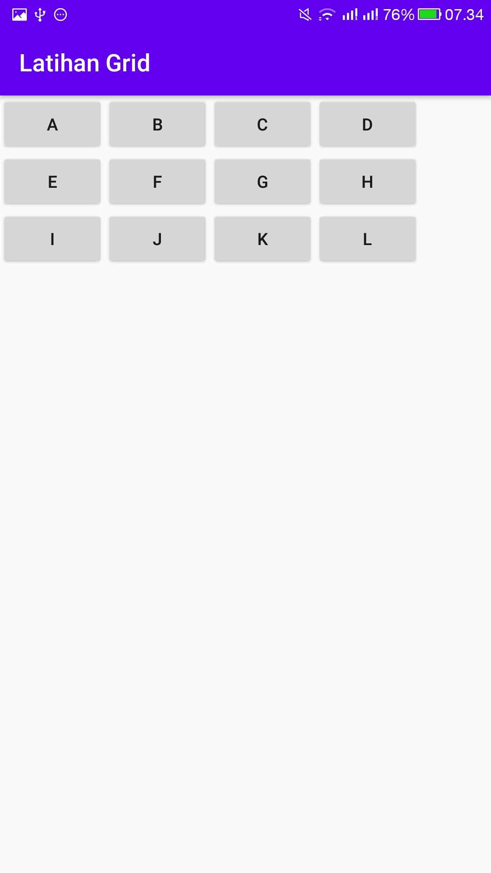

3. Latihan Constraint Layout : https://github.com/aditpp/android_studio/tree/master/ConstraintLayout
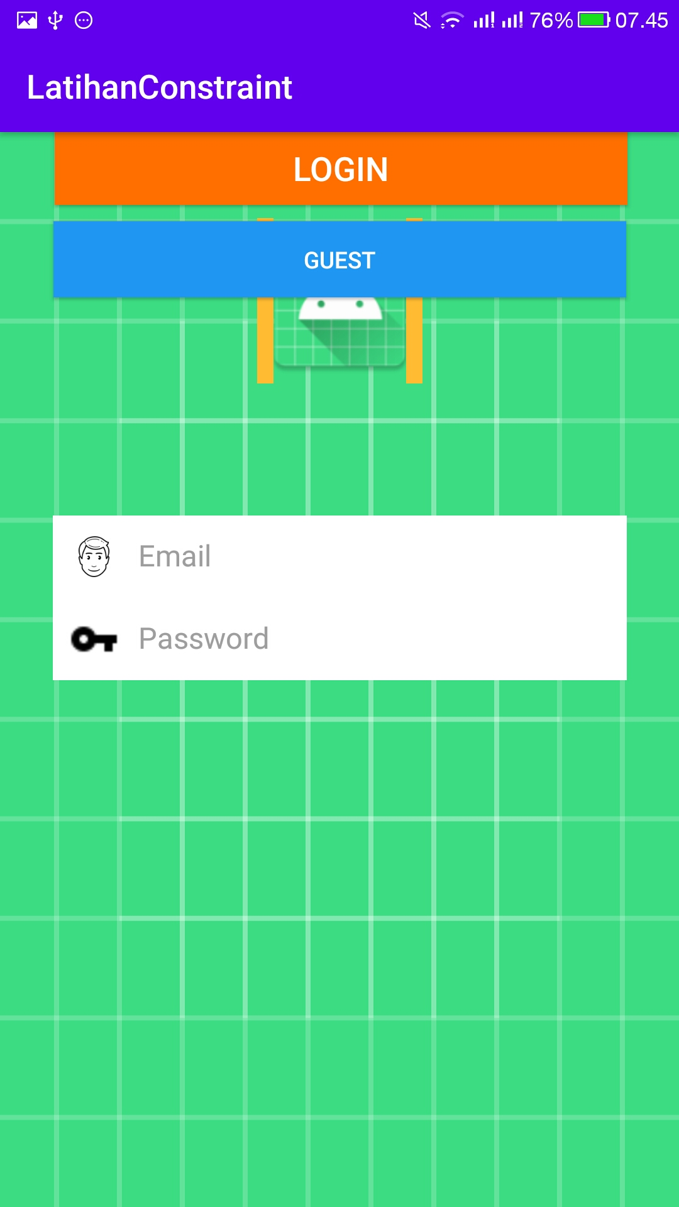

4. Latihan Intent : https://github.com/aditpp/android_studio/tree/master/LatihanIntent

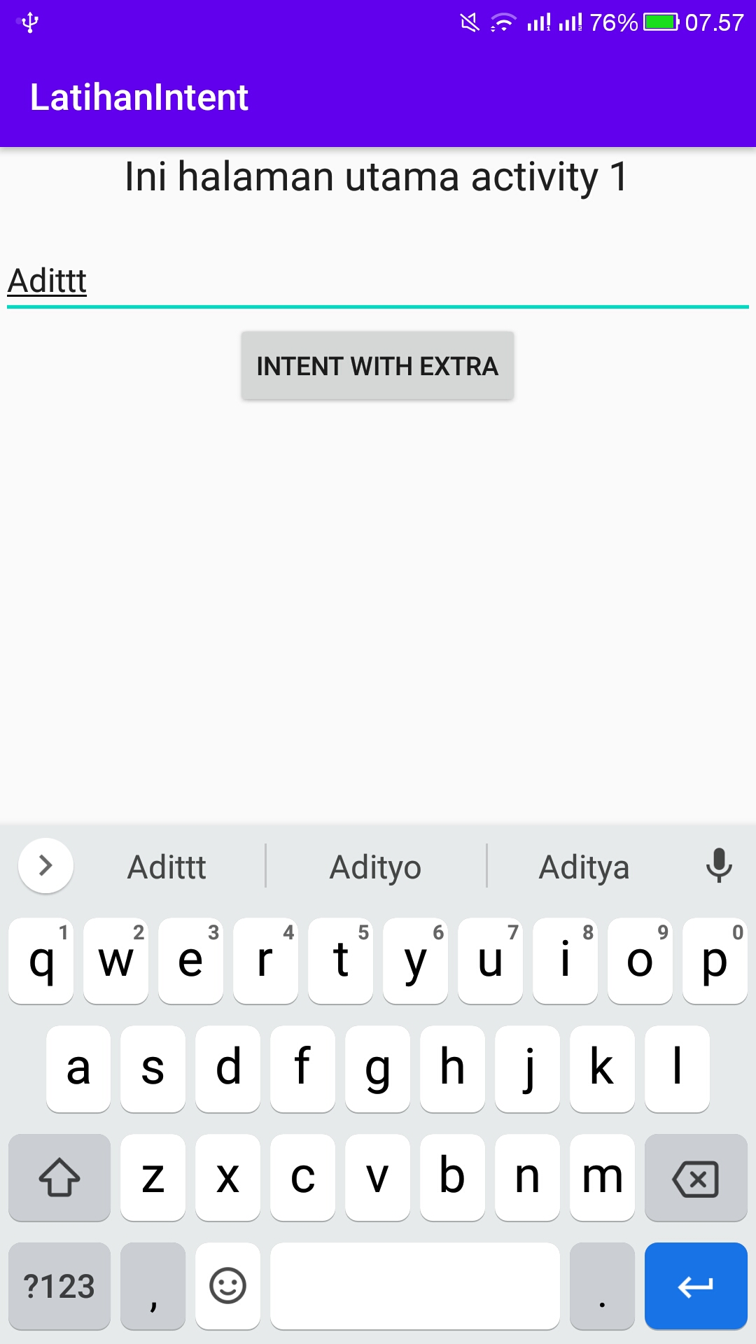
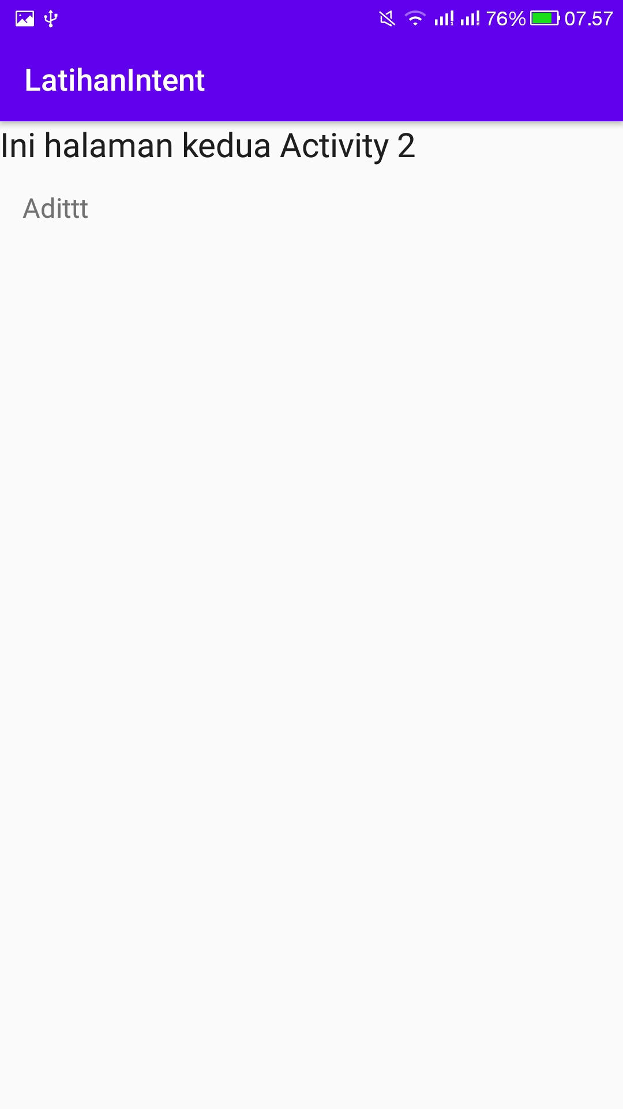

5. Latihan Intent 2 : https://github.com/aditpp/android_studio/tree/master/LatihanIntent2

